**REGex Software Services**

**Java Full Stack Development Program**

Registration I'd:  **IIPRSS1404**

Name: **Shanmukh Subhash Kumbhar**

# Subject: Assignment 5 - #Control Flow Statements

Core Java 2021 **Core Java Session 5 Assignments**

1. Accept year and find whether given year is Leap year or not.

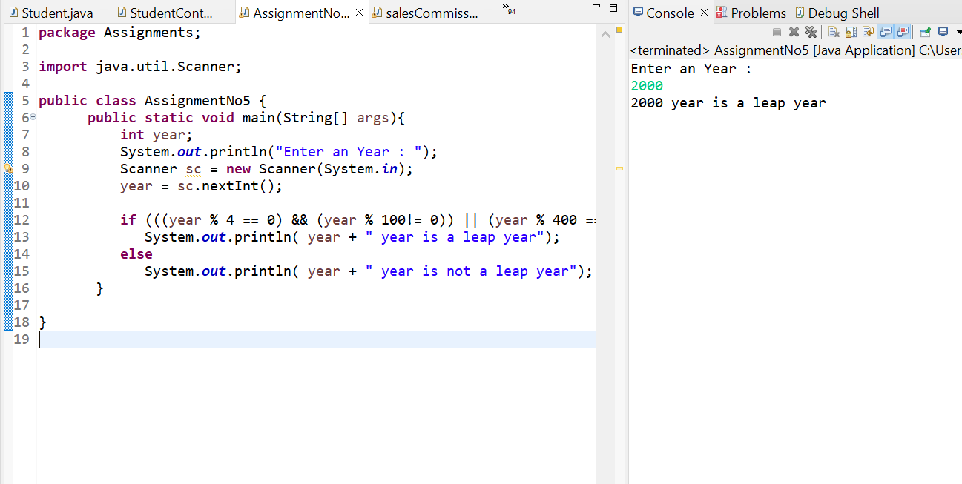

1. Accept **Age** from console and find whether a person is eligible to vote or not.

3. Accept a number dynamically and find sum, reverse and no of digits in the given numbers. Input:

123

Output:

Sum: 6

Reverse: 321

Count: 3

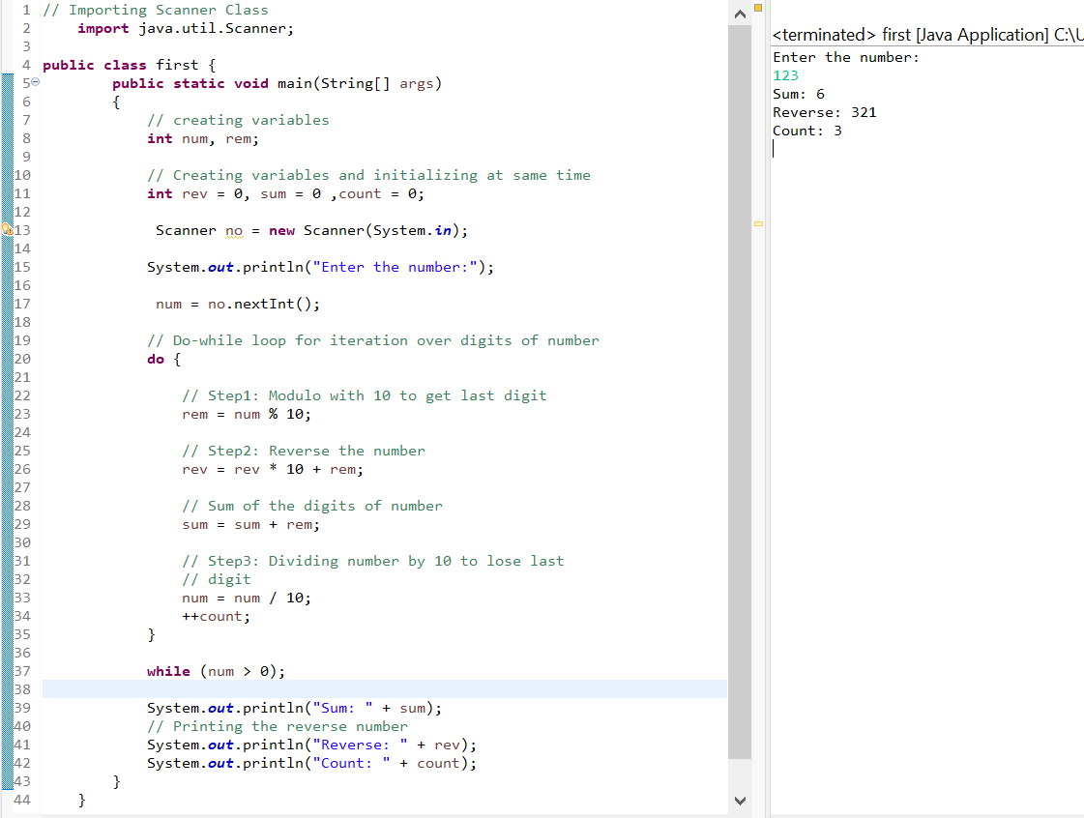

4. Write a program to find sum of the first natural numbers up to the given numbers.

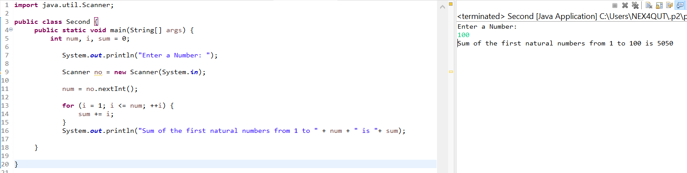

5. Write a program to check the given number is prime or not.

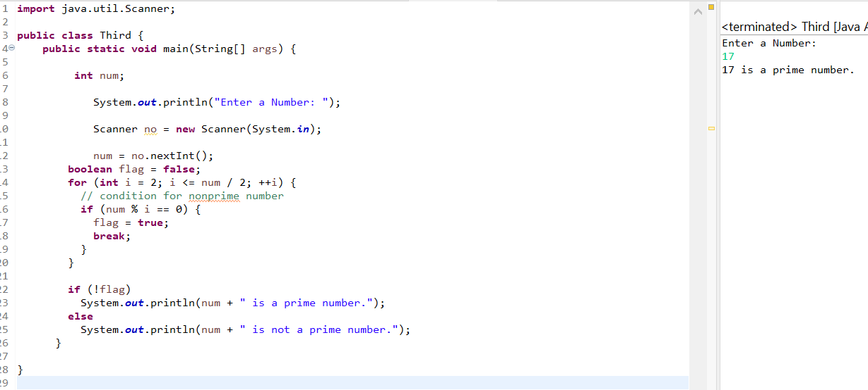

6. Write a program to print prime numbers up to the given number.

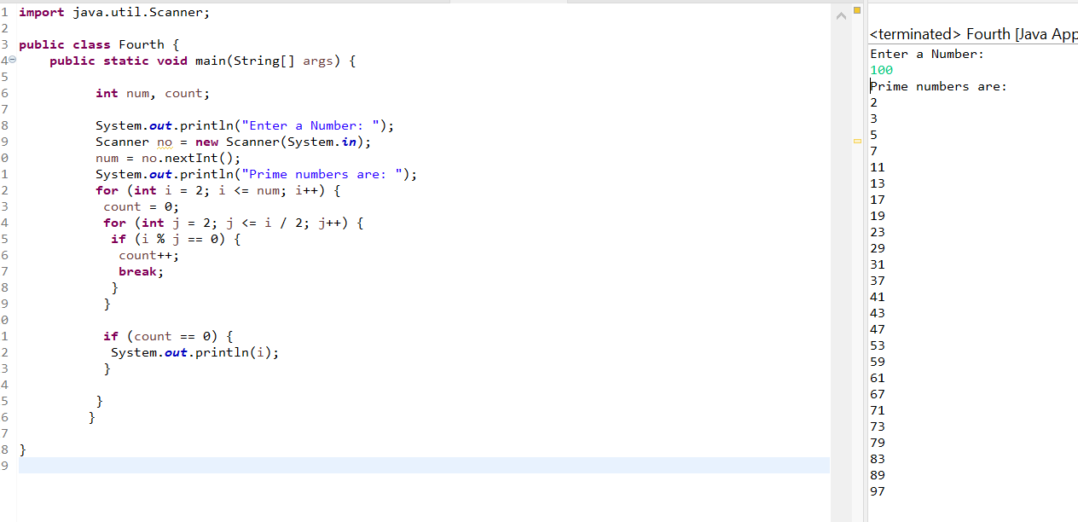

7. Write a program to check whether given number is palindrome or not.

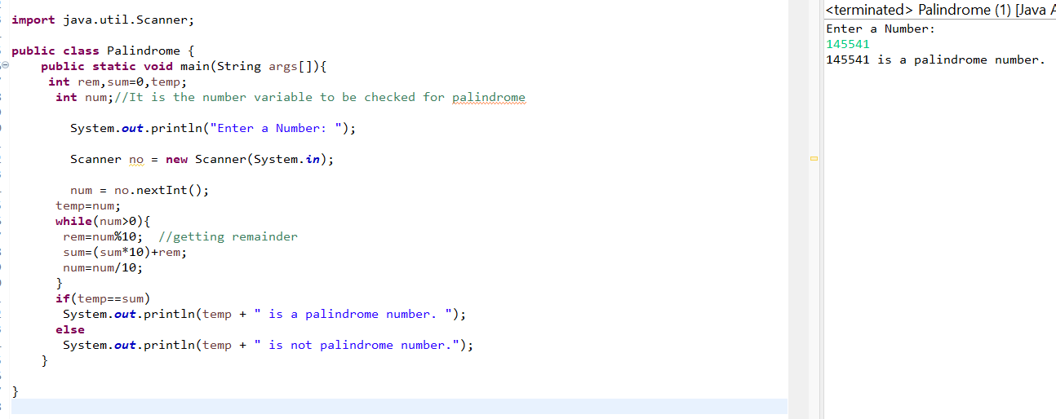

8. Write a program to print factors of the given number.

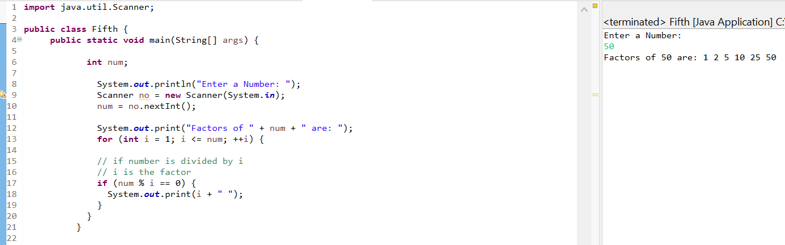

9. Develop **Sales Commission App**

Calculate **commission** based on the following criteria

Sales Commission

------ ----------------

0 - 10000 0%

10001-20000 10%

20001-30000 20%

30001 - rest 25%

Print **Sales amount, Comm and total**

10. Develop a menu-based ***Calculator App*** with operations like **ADD, SUB, MUL** and **DIV** using do-while.

**Page 1**